Insert your name, centre number and candidate number into the header above.
Save this evidence document as evidence_ followed by your centre number_ candidate number. For example: evidence_ zz999_9999.doc
Screenshots or program listings must be copied into appropriate cells in the following tables.
Examiners must be able to read the contents including any screenshots without the use of a magnifying glass. Answers that are not readable or missing will not be awarded any marks.
Save this evidence document at regular intervals, for example, every 10 minutes.
Question 1
Part 1(a)
{Copy and paste program code listing for question 1(a) here}

global Queue # DECLARE Queue: ARRAY[0:19] OF INTEGER
global HeadPointer
global TailPointer
global NumberItems

#main
Queue=[-1 for _ in range(20)]
HeadPointer=-1
TailPointer=-1
NumberItems=0

Part 1(b)
{Copy and paste program code listing for question 1(b) here}

def Enqueue(Num):
global Queue
global HeadPointer
global TailPointer
global NumberItems

if NumberItems>=20:
return False

NumberItems+=1
TailPointer+=1
if TailPointer>=20:
TailPointer=0
if HeadPointer==-1:
HeadPointer=0
Queue[TailPointer]=Num
return True

Part 1(c)
{Copy and paste program code listing for question 1(c) here}

for i in range(1,26):
if Enqueue(i): print(f"{i} Successful")
else: print(f"{i} Unsuccessful")

Part 1(d)
{Copy and paste program code listing for question 1(d) here}

def Dequeue():
global Queue
global HeadPointer
global TailPointer
global NumberItems

if NumberItems<=0:
return -1

NumberItems-=1
Item=Queue[HeadPointer]
HeadPointer+=1
if HeadPointer>=20:
HeadPointer=0

return Item

Part 1(e)(i)
{Copy and paste program code listing for question 1(e)(i) here}

print(Dequeue())
print(Dequeue())

Part 1(e)(ii)
{Copy and paste screenshot for question 1(e)(ii) here}

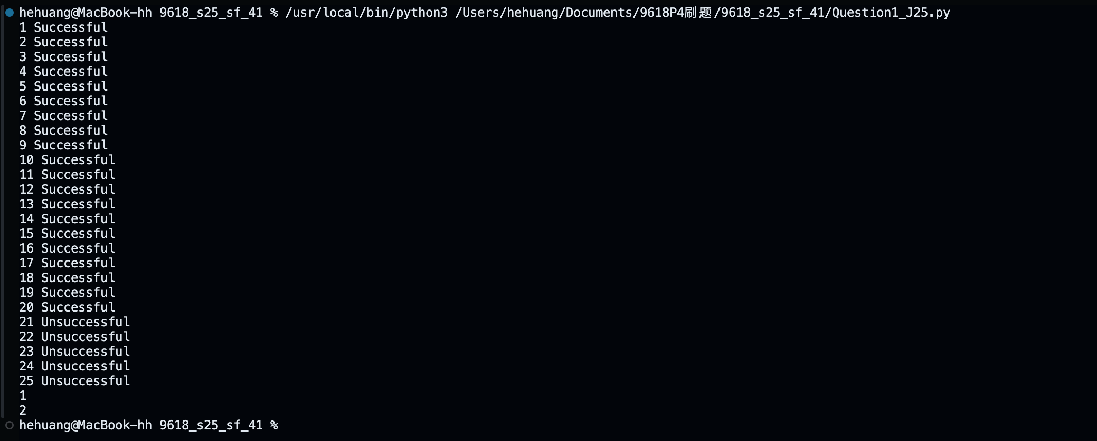

Question 2
Part 2(a)
{Copy and paste program code listing for question 2(a) here}

def ReadData():
try:
Name=input("Enter a file name. ")
f=open(Name,'r')
x=f.readline().strip()
Array=[]
while x!="":
Array.append(x)
x=f.readline().strip()
f.close()
return Array
except IOError:
print("File not found")

Part 2(b)
{Copy and paste program code listing for question 2(b) here}

def SplitData(DataArray):
Red=[]
Green=[]
Blue=[]
Orange=[]
Yellow=[]
Pink=[]
for Data in DataArray:
Item=Data.split(',')
if Item[1].lower()=="red":
Red.append(int(Item[0]))
elif Item[1].lower()=="green":
Green.append(int(Item[0]))
elif Item[1].lower()=="blue":
Blue.append(int(Item[0]))
elif Item[1].lower()=="orange":
Orange.append(int(Item[0]))
elif Item[1].lower()=="yellow":
Yellow.append(int(Item[0]))
elif Item[1].lower()=="pink":
Pink.append(int(Item[0]))

Part 2(c)
{Copy and paste program code listing for question 2(c) here}

def StoreData(DataToStore,FileName):
try:
fw=open(FileName,'a')
for item in DataToStore:
fw.write(str(item))

fw.close()
except IOError:
print("File not found or cannot be written")

Part 2(d)
{Copy and paste program code listing for question 2(d) here}

def SplitData(DataArray):
Red=[]
Green=[]
Blue=[]
Orange=[]
Yellow=[]
Pink=[]
for Data in DataArray:
Item=Data.split(',')
if Item[1].lower()=="red":
Red.append(int(Item[0]))
elif Item[1].lower()=="green":
Green.append(int(Item[0]))
elif Item[1].lower()=="blue":
Blue.append(int(Item[0]))
elif Item[1].lower()=="orange":
Orange.append(int(Item[0]))
elif Item[1].lower()=="yellow":
Yellow.append(int(Item[0]))
elif Item[1].lower()=="pink":
Pink.append(int(Item[0]))

StoreData(Red,"Red.txt")
StoreData(Green,"Green.txt")
StoreData(Blue,"Blue.txt")
StoreData(Orange,"Orange.txt")
StoreData(Yellow,"Yellow.txt")
StoreData(Pink,"Pink.txt")

Part 2(e)(i)
{Copy and paste program code listing for question 2(e)(i) here}

#main
DataItems=ReadData()
SplitData(DataItems)

Part 2(e)(ii)
{Copy and paste screenshot(s) for question 2(e)(ii) here}

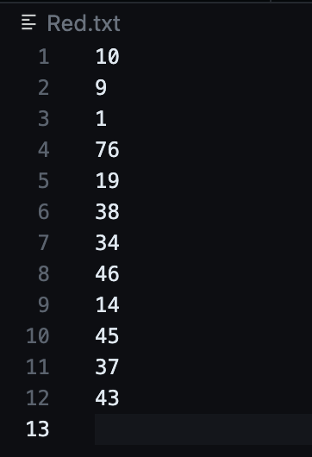
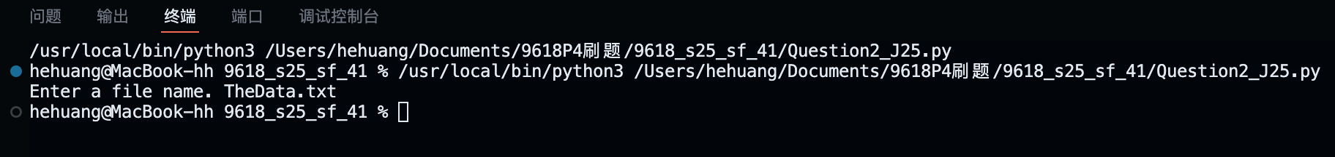

Question 3
Part 3(a)(i)
{Copy and paste program code listing for question 3(a)(i) here}

class Node:
def __init__(self,nd):
self.__NodeData=nd # PRIVATE NodeData: INTEGER
self.__LeftNode=None # PRIVATE LeftNode: INTEGER
self.__RightNode=None # PRIVATE RightNode: INTEGER

Part 3(a)(ii)
{Copy and paste program code listing for question 3(a)(ii) here}

def GetLeft(self): return self.__LeftNode
def GetRight(self): return self.__RightNode
def GetData(self): return self.__NodeData

Part 3(a)(iii)
{Copy and paste program code listing for question 3(a)(iii) here}

def SetLeft(self,node): self.__LeftNode=node
def SetRight(self,node): self.__RightNode=node

Part 3(b)
{Copy and paste program code listing for question 3(b) here}

#main
Node1=Node(10)
Node2=Node(20)
Node3=Node(5)
Node4=Node(15)
Node5=Node(7)

Part 3(c)(i)
{Copy and paste program code listing for question 3(c)(i) here}

class Tree:
def __init__(self,fn):
self.__FirstNode=fn # PRIVATE FirstNode: Node

Part 3(c)(ii)
{Copy and paste program code listing for question 3(c)(ii) here}

def GetRootNode(self): return self.__FirstNode

Part 3(c)(iii)
{Copy and paste program code listing for question 3(c)(iii) here}

def Insert(self,NewNode):
Current=self.GetRootNode()
Found=False
while not Found:
if NewNode.GetData()<Current.GetData():
if Current.GetLeft() is None:
Current.SetLeft(NewNode)
Found=True
else:
Current=Current.GetLeft()
else:
if Current.GetRight() is None:
Current.SetRight(NewNode)
Found=True
else:
Current=Current.GetRight()

Part 3(d)
{Copy and paste program code listing for question 3(d) here}

def OutputInOrder(ANode):
if ANode.GetLeft() is not None: OutputInOrder(ANode.GetLeft())
print((ANode.GetData()))
if ANode.GetRight() is not None: OutputInOrder(ANode.GetRight())

Part 3(e)(i)
{Copy and paste program code listing for question 3(e)(i) here}

Tree1=Tree(Node1)
Tree1.Insert(Node2)
Tree1.Insert(Node3)
Tree1.Insert(Node4)
Tree1.Insert(Node5)
OutputInOrder(Tree1.GetRootNode())

Part 3(e)(ii)
{Copy and paste screenshot for question 3(e)(ii) here}

